Host Checklist
Booking Enquiry
1 | Ensure you meet the Host Requirements.
2 | Identify a suitable venue. Venue Requirements
3 | Identify available dates using the Mobile Skills Unit Calendar.
4 | Contact Lynn Hardie, Mobile Skills Unit Senior Officer at nes.msu@nhs.scot to request a booking form. Alternatively fill out the enquiry form here.
5 | Complete the booking form and return it to nes.msu@nhs.scot. Your booking is not confirmed until you receive a confirmation email.

Before the Visit – Logistics
1 | Agree arrival and departure times with Lynn Hardie.
2 | Confirm who will meet the driver to take responsibility for the keys. Share contact information with Lynn Hardie.
3 | Provide Lynn Hardie with directions to the parking site, map and any additional information regarding site access.
4 | Ensure you have received an email from Lynn Hardie confirming all visit details and a statistics form. QR codes for the evaluation are below.

Before the Visit – Training Programme
1 | Start planning your training programme in collaboration with your chosen venue.
2 | Check the equipment you require is onboard the unit. Equipment Guide. Some models are available on request only. Please email nes.msu@nhs.scot with any requests for additional equipment at least 6 weeks prior to the visit. Consumables must be provided by the venue.
3 | Advertise and take bookings for your programme.
4 | Send your final training programme to nes.msu@nhs.scot. You can use this Training programme template.

During the Visit
1 | Encourage participants and facilitators to complete the MSU evaluation forms by scanning the QR codes on the Mobile Skills Unit.
2 | Set up and pack away all the equipment with care.
3 | Ensure the Mobile Skills Unit is clean before it departs. Remove all waste.

After the Visit
1 | Send a completed MSU Statistics Form to nes.msu@nhs.scot
2 | Share photos with the CSMEN team.
3 | Feedback any issues with equipment or the Mobile Skills Unit to nes.msu@nhs.scot

Useful Information
The Mobile Skills Unit pages on the CSMEN website include all the information you require to host a training session.
The Frequently Asked Questions page is another useful tool.
CSMEN have developed evidence-based, quality-assured online educational resources. These can be accessed via Turas Learn.
Evaluation
Please encourage participants and facilitators to complete the MSU evaluation forms by scanning the QR codes which are on the MSU and below.
Participant MSU Evaluation Form QR Code:
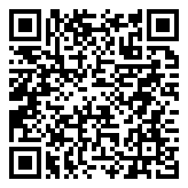
https://response.questback.com/nhseducationforscotland/msuevalform
Facilitator MSU Evaluation form QR code:
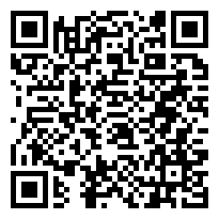
https://response.questback.com/nhseducationforscotland/msufacilitatorevalform

Key Contacts
Lynn Hardie Mobile Skills Unit Senior Officer (Tues-Fri)
Email: lynn.hardie@nhs.scot Phone 01382 932795 Mobile: 07795 796083
CSMEN - General Enquiries
Email: nes.msu@nhs.scot Phone 01382 932377 (Mon-Thur) 01382 932 791 (Thur -Fri)

